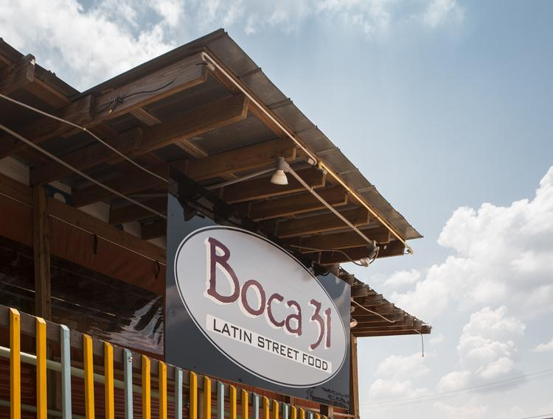

**Strategic Brand Management Mid-Term Report**

Professor Guzman

Jonathan Compton

Megan Fountain

Amanda Fredrick

Emma Hamilton

Chris Lederer

Alicia Morgan

**Introduction:**

Boca 31 brings authentic flavor to Denton by highly acclaimed Chef Andres. Boca 31 serves an assortment of Latin Street food. The made from scratch empanadas are the only ones in Denton. The menu is always changing based on what is fresh and in season. Chef Andres offers anyone who comes to Boca 31 a tasty and unique experience.

**Mission statement:**

A mission statement is a written statement of an organization’s core purpose and focus that typically remains the same over time. Based on what we have learned about Boca 31, we have created a mission statement that focuses on the solutions of offering Latin street food in an environment that treats customers like family. We chose the words “home” and “family” because Andres’ wants his customers to feel like they’re in his home. He wants to constantly smile and be nice to people, which is exactly how he would act towards his family members. They take care of their customers and treat them with respect. These are some of the things that Boca 31 holds as their values.

Mission: *“To transport you to the home of Chef Andres through an ever-evolving Latin inspired menu and treating you like part of the family.”*

**Reference Market:**

It can’t be stressed enough that Chef Andres loves making his customers feel welcome and at home, hence where the word “home” comes in.

The reference market distinguishes a portion of the total market to offer the best advantages to the firm. It must be expressed in terms of a solution. It is the process of narrowing down everyone we can sell our product or service to. In this market, there is need to understand what is satisfied (functions/needs), who is satisfied (B2B, B2C, B2G), and how it is satisfied (technologies used).

* **Who:** Boca 31 is currently operating under a Business to Consumer (B2C) model.
* **What:** What is being satisfied is the “home away from home” experience. What Boca 31 provides to its consumers is a warm, welcoming and “home-feeling” environment that allows you to thoroughly enjoy the unique Latin food that is being served. Chef Andres brings the home to you when you walk into Boca 31. His open-concept kitchen allows his customers to see the preparation and attention to detail that goes into every dish. As you walk inside you feel the warmth of his staff. The colorful, tasteful food allows one to immediately feel at ease as it is being prepared, as they would as if it they were preparing it themselves in their own home.
* **How:** The “home away from home” experience can be satisfied by other alternatives as well. People could could satisfy this need by: family run restaurants, full chain restaurants, other fast-casual establishments, food trucks, bed and breakfasts, and salons/spas.

**Internal and External Analysis:**

This section will serve as an analysis of the behaviors, actions, and decision made within and out of the company. This allows for an understanding of the consumer, competition, and the brand itself. The strategic analysis of a brand includes the intra-organizational environment, the task environment, markets, competitors, publics and the macro-environment.

* **Intra-Organizational Environment**
* **Hierarchy:**

The owner is Andres Meraz. There are cashiers, cooks, prep cooks and dishwashers. There is also a chef that works with him that is second in command.

* **Products/Services**:

The popularity and profitability numbers could be better tracked using a POS system such as Clover or Square Point of Sale, both of which are on the very affordable side of the spectrum. The popularity and profitability rankings demonstrate the opportunity to increase popularity of higher profit items through specials, and the possibility to incrementally increase prices on best sellers where deemed fit.

* Best sellers (best to worst):
  + Empanadas
  + Tacos
  + Special
  + Sandwiches
  + Sides
  + Rice and bean bowls
  + Salad
* Profitability (most to least):
  + Sandwiches
  + Specials
  + Tacos
  + Sides
  + Salads
  + Rice and bean bowls
  + Empanadas

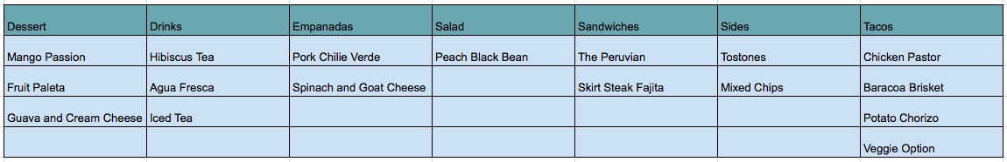

* **Main Clients:**

Boca 31 is conveniently located off of I 35 E, in the downtown Denton square area. Most of their main clients are teachers and utility workers. Their main peak times are during the lunchtime hours. Boca 31 is very quick to make their customers’ orders and get it out to them, which plays a huge part in how convenient it is. It’s a spot for them to grab a quick lunch during their break and head back to work.

* **Task Environment:**

Boca 31 is located in Denton, TX which is a community influenced by having access to local food. Boca 31 fulfills this need by using ingredients from US foods, small grocery stores, and locally grown herbs. Creating food handmade is how Chef Andres shows off his passion for cooking with an influence of Latin America.

**Product Suppliers:**

* Grows his own herbs, peppers(seasonal)
* US Foods
* Used to have several vendors, only using one now
* Grocery store for small items

**Business relationships** - knows a few owners locally but that’s it

* **Markets:**

The total market, ,the four county area of Denton (pop. 806,180), Collin (pop. 939,585), Tarrant (pop. 2,016,872), and Dallas (pop. 2,574,984), has a population of 6,337,621 per the 2016 census projection. According to Bright Local’s survey in 2014, the average consumer is willing to drive 17 minutes to a restaurant. This reduces the potential market to 806,180.

2017 Gallup research shows that consumers in the age group 18-34 (pop. 174,052 of 20-34 per 2016 census projection) and 35-54 (pop. 242,128 per 2016 census projection) dine out most frequently, making the available market 416,180.

Per the same 2017 Gallup research, 72% of those 18-34 and 65% of those 35-54 dine out once per week. This establishes our target market of 282,717, or 4.4% of the total market.

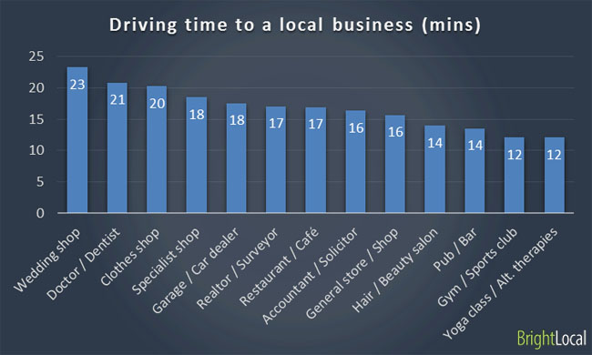

* **Competitors:**

|  |  |
| --- | --- |
| **Brand Competitors**   * Mi Casita * Mr. Chopsticks * Cracker Barrel | **Product Form**   * Grocery Stores (shop & cook at home) |
| **Desire Competitors**   * Full Service Restaurants * Fast-Casual Restaurants * Food Trucks * Salons & Spas | **Generic Competitors**   * Farmers Market Latin Food |

* **Brand Competitors**

When analyzing Boca 31’s brand competitors we felt it important to reference other fast-casual and full-service restaurants that invoke a familiarity and comfort, reminiscent of the customer’s home.

* **Mi Casita:**

Mi Casita is a locally owned, Mexican Restaurant centrally located in Denton, TX. This casual counter-serve restaurant is known for their selection of fresh and authentic mexican food. Additionally, they’re the winner of the 2017 City Beat News’ award for ‘*Excellence in Customer Service*’. This locally owned, fast-casual restaurant that strive to provide fresh and authentic food, serves as a worthy competitor for Boca 31.

* **Mr. Chopsticks:**

Mr. Chopsticks is a locally owned, full service restaurant that serves Asian inspired dishes in a casual setting. It has been serving uniquely serving Dentonites since 1985. The restaurant serves customers in a drive through as well as a full service restaurant. The Denton-Record Chronicle recognized the long standing establishment at one of the “Best in Denton” in 2016.

* **Cracker Barrel:**

Cracker Barrel is a large chain restaurant that has 645 stores in 44 states. Though a large chain restaurant, Cracker Barrel is included in the list of competitors because they strive to “set an iconic American family table for generations to come”. So, even though this restaurant is not considered fast-casual, like Boca 31, the home-away from home essence as well as the brand recognition makes the restaurant a competitor.

* **Product Form**

Product form alternatives for Boca 31 consists of other forms of the product that could fulfill the customer’s desire for a “home away from home experience”. Alternate form of this may include visiting the grocery store and purchasing the ingredients to make the Latin food at their own homes.

* **Desire Competitors**

These are others that can satisfy the need for a “Home Away from Home Experience”

For us this includes locally owned restaurants, full chain restaurants, other fast-casual establishments, Food Trucks, and Salons/Spas.

* **Full Service Restaurants:**

Full service restaurants provide guests with a more comprehensive dining experience. Unlike Boca 31, at these establishments, customers are able to place an order without moving from their table. The presence of waitstaff means that the customers can also order drinks and desserts without having to wait in a line. Additionally, there is no need to clear the plates from the table, as they are done for you. Restaurants that fall into this category include, Cracker Barrel, Chuy’s, Chilis’, and many more.

* **Fast-Casual Restaurants:**

Fast-casual restaurants, like Boca 31, provide customers with a faster dining experience that doesn’t skimp on the quality. At these establishments, customers usually order at a counter and then are in-charge of clean up after finishing their meals. Examples of fast-casual restaurants include Chipotle, Torchy’s Tacos, and Pei Wei.

* **Food Trucks:**

Food Trucks are restaurants on wheels that are often found in one area. These establishments offer customers a small menu of choices, consisting of high-quality, specialized foods. In Denton, there are food truck ‘parks’ that host a multitude of food trucks. These parks include *Backyard on Bell* and *Austin St. Truck Stop.* Examples of food trucks at these locations include The Waffle Wagon, Flatlander’s Taco Company, and Leila’s Middle Eastern Fusion.

* **Salons & Spas:**

Salons & Spas provide a variety of services for customers such as nail services, facials, and massages. These services are fairly similar for each customer regardless of the location in the country that the service is done. The knowledge that a customer can enter a salon or spa anywhere in the world, and know exactly what to expect gives the customer a sense of home wherever they are. Spa 940, Deluxe Nails & Spa, and Essentials Day Spa are all local establishments that fit under this category.

* **Generic Competitors**

Generic competitors of Boca 31 consist of people who make traditional Latin food for either themselves, or to be sold at farmer’s markets.

* **Publics:** 
  + - **Local:** Located in Denton, TX Boca 31 has a variety of customers. Teachers who work at TWU, UNT, private Schools, or public schools provide Boca 31 with lots of regular customers for lunch. As well as other local business provide plenty local customers. Since a large portion of Boca 31’s customers are regulars, this allows them to have an opportunity to provide customers with a free meal to returning customers after a number of visits.
    - **Media:**

In July of 2016, Boca 31 was featured in the Denton Record Chronicle article,” Boca 31 serves up Latin flair.” The next month, the Dallas Observer reached out to Chef Andreas and wrote an article on the restaurant. This type of positive exposure is needed for the success of a small business. Boca 31 has a full 5 out of 5 stars from 215 reviews on Yelp, which is a service that Andreas does not subscribe to. However, they do not pay for commercials across any media platform.

* **Government:** Boca 31 is governed by the rules of the Texas Department of State Health Services as a food service establishment. This is the primary source of their permits. They also have to adhere to the rules of the Texas Alcoholic Beverage Commission, as they serve beer and sangria. They are also governed by city and local ordinances and must pay sales tax to the proper agencies.
* **Consumer Affairs**: Consumer affairs deals with local advocacy groups and organizations that concern themselves with a product or service within Boca 31. Keep Denton Beautiful is a nonprofit organization that advocates for business and citizen alike to protect the environment . SHOP Denton is city run program that encourages Dentonites to shop and eat local. Additionally, the Better Business Bureau, as an independent agency will also be concerned with the operation of Boca 31
  + - **General:** Potential Clients to collaborate with include the Fire department (across the street), The Art School Next Door, and the Armadillo (being built next door). These potential clients could provide collaboration with Boca 31.
* **Macro-Environment:**
  + - **Political:**
      * Zoning Changes: Zoning changes can be requested if the owner of the property would need to change the venue space however in Boca 31’s case their restaurant is properly zoned since Andres is renting the space.
      * Labor Laws: Can affect how Chef Andres runs his business by the amount of hours each employee can work. As well as base pay for each employee. These can affect his expenses.
    - **Economic:**
      * Threat of Possible Recession: The economy is always changing and when there is a recession the first thing most people cut out is eating out.
      * Supplier Cost Increases: Due to the changing climate Boca 31 could have increasing changes in costs.
      * Rent Increases: Since Andres doesn't own his property he could have issues with the landlord changing his rent. This could affect the profitability of his business.
    - **Socio-Cultural:**
      * Stay on Facebook
      * Negative press revolving around their products or suppliers: Since Chef Andres advertises latin street food his whole goal is to have fresh food. By saying this he must choose his suppliers wisely in order to stay consistent with his brand.
    - **Technological:** 
      * Lack of POS System: They must enter in everything manually causing the line to back up. Having a POS system would create a much easier ordering process as well as keeping an accurate list of what they have in stock.
      * Manually researches market prices depending on the day: Productivity is decreased because it takes longer for someone to search market prices.
    - **Legal:** 
      * TABC: Making sure that Boca 31 is certified and displays proper certification in restaurant.
      * Texas State Department of Health: Boca 31 must keep things clean, well maintained, and permits up to date in order to be open as a restaurant.
    - **Environment:** 
      * Weather (because a large portion of his seating is outside): Boca 31 has covers to enclose their large patio. As well heaters to maintain a pleasant atmosphere for its customers.

**Solution Life Cycle:**

The solution life cycle represents the distinct phases of a product/service lifecycle. It has seven phases which include the introduction phase, accelerated growth phase, slow growth phase, shake off phase, maturity phase, decline phase, and residuality phase.

To determine the present stage of the Solution Life Cycle for Boca 31, we analyzed each technology that can satisfy the home-away-from-home experience. We then analyzed what stage of the life cycle each technology is in. Below is the list of stages of the solution life cycle of each technology:  
   
Introduction Phase = 1  
Accelerated Growth Phase = 2  
Slow Growth Phase = 3  
Shake-Out Phase = 4  
Maturity Phase = 5  
Decline Phase = 6  
Residuality Phase = 7

* **Family owned restaurants - Slow Growth Phase (3)**

According to a report in Nation’s Restaurant News, research from Pentallect, Inc. estimates a 4 to 5 percent growth for independent restaurants during 2017-2020, slightly outpacing inflation.

* **Chain restaurants - Maturity Phase (5)**

The report from NRN and Pentallect, Inc. referenced above indicates only a 2 to 3 percent growth for chains during the same period, basically keeping pace with inflation for flat growth.

* **Fast casual restaurants - Slow Growth Phase (3)**

Pentallect, Inc. forecasts growth of 6 to 7 percent during the 2017-2020 period for fast casual restaurants. This is down from 8 to 10 percent in prior years. Problems include growth reliant on new businesses as opposed to same store sales, and limited new menu offerings reducing consumer draw.

* **Food trucks - Slow Growth Phase (3)**

Food trucks have seen meteoric growth since 2008, but that growth is beginning to slow. IBIS reports that this slowing growth will continue due to municipalities further tailoring city ordinances. It will also slow to due to basic saturation.

* **Nail salons / spas - Slow Growth Phase (3)**

IBIS reports that due to new products and services, increases in disposable income, and low barriers to entry, the market has grown steadily and will continue to do so.

* **Boca 31 (3.4)**

Boca 31 is experiencing the slow growth phase. They have come to a point where the rate of openings has slowed, and even looking specifically at the Boca location, only 1 of the last 3 businesses in the location actually moved due to growth; the others closed their doors or pulled out of Denton. Now is the time to strengthen the brand, lock in on the market segment, and optimize pricing and special offerings.

**Strategic SWOT Analysis:**

The strategic SWOT analysis is a breakdown of the environmental data, opportunites, threat, strengths, weaknesses, and actions. This breakdown helps you focus on the strengths, the weaknesses you need to fix, the opportunities you need to act on, and the threats that can

possibly hurt you.

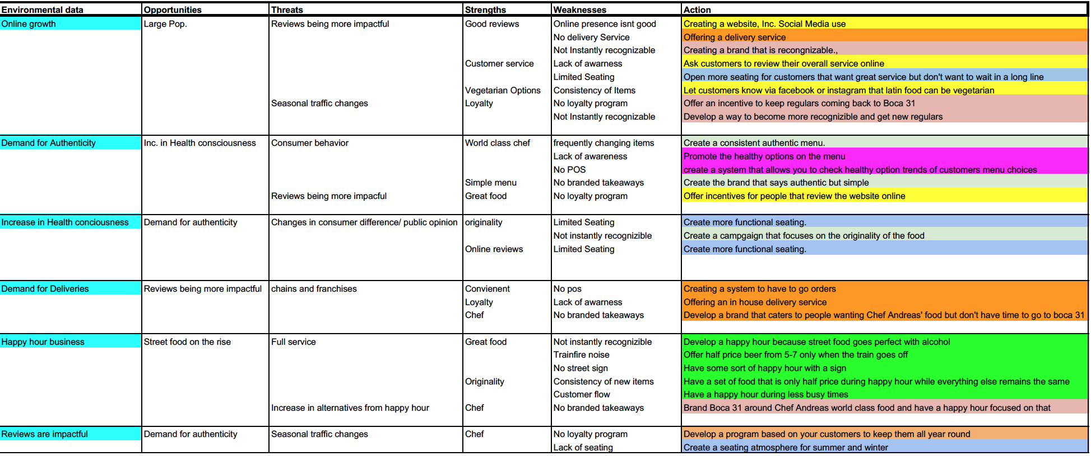

The strategic SWOT for Boca 31 focuses on the analysis of six different environmental factors within the restaurant industry. Each factor was then analyzed based upon potential opportunities, threats, strengths and weaknesses. The information gathered in this analysis led to the development of several differing actions that Boca 31 can take in order to strengthen their position within the market. Of these, are actions such as the creation of a happy hour special, improvement of physical presence, and enhancing online presence.

**Brand Identity:**

Brand Identity is how Boca 31 feels that its image or brand should be represented. During the experience, the customer and team members of Boca 31 will establish a relationship that radiates from the essence of the brand all the way to the outer core, or the extended part of the core identity.

* + **Brand Personality:**

Boca 31’s brand personality is a hard working family man. This individual is dedicated and passionate about his work. He is warm and inviting and makes everyone he meets feel like family. He exudes sincerity and operated in a spirited manner.

* + **Brand Identity Structure:**
* Brand Essence: The “home-away from home” experience
* The Core Identity: Customer Service, Quality Food, Value, Relaxed Atmosphere
* The Extended Identity: Lack of online presence, changing menu, seating layout

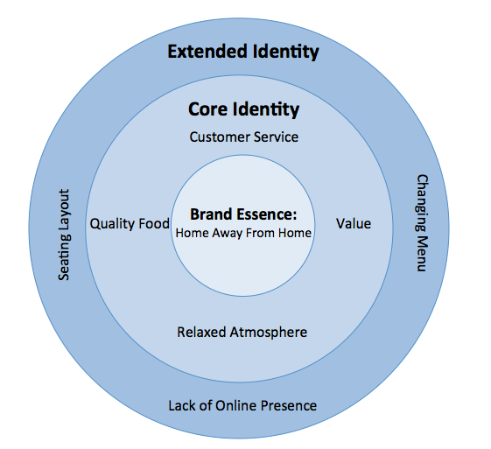

**Segmentation:**

Segmentation is the process of splitting the total market into groups of clients. Segmentation helps determine the appropriate group of people to market a service or product to because consumers have various levels of brand knowledge which lead to different perceptions and preferences of a brand. Segmentation can be broken up into two parts: macro-segmentation and micro-segmentation. The Macro-segmentation process divides the consumers into a basic group of those who use the product or service versus those who do not. The Micro-segmentation process gets into the finer details about which types of consumers Boca 31 will want to approach.

1. **Reference Market**
   * What - Home-away-from-home experience
   * Who - B2C
   * How - Restaurants, food trucks, salons
2. **Macro-Segment**

Boca 31 delivers the home-away-from-home experience to individuals through their homey restaurant atmosphere and their authentic, from-scratch food.

1. **Detecting Variables for Micro-Segmentation**

When consumers eat at Boca 31 the benefits they are searching for are those related to the home-away-from-home concept. Consumers are looking for a casual, homey atmosphere where they can feel relaxed as they do at home. They are looking for service that can only be paralleled by the family treatment, and food so authentic you would think Grandma made it herself using the family recipe. Dining out is not cheap, but when consumers eat at Boca 31 they expect the price to be similar to what it would cost to buy the ingredients and make it at home.

|  |  |  |
| --- | --- | --- |
| **Searched Benefit** | **Socioeconomic Variables** | **Psychographic Variables** |
| casual atmosphere | age | health conscious |
| family treatment | gender | travelers |
| authentic food | income | working people |
| pricing | ethnicity | college students |

1. **Electing Variables for Micro-Segmentation**
   * Degree of interest in authentic food
   * Degree of time spent working
2. **Operationalization of Variables**
   * Degree of interest in authentic food
     + % of meals eaten that were cooked from scratch
   * Degree of time spent working
     + # of hours in workweek
3. **Micro-Segmentation**
   * Degree of interest in authentic food

(% of meals eaten that are cooked from scratch)

* Low: 0-20%
* Medium: 21-60%
* High: 61-100%
* Degree of time spent working

(# of hours in workweek)

* Low: 0-20 hours
* Medium: 21-40 hours
* High: 41+ hours

|  |  |  |  |  |
| --- | --- | --- | --- | --- |
|  |  | **Degree of interest in authentic food** | | |
|  |  | **Low** | **Medium** | **High** |
| **Degree of time**  **Spent working** | **High** | Fast-food junkies | Carry-outters | Quick-servers |
|  | **Medium** | Microwavers | Indecisives | Pinteresters |
|  | **Low** | Preheaters | Crockpotters | Home “Chefs” |

1. **Electing Target Segments**

We elected these target segments because we believe these are the most accessible, profitable, and homogenous segments for Boca 31. These segments consist of the busier people with at least moderate interest in authentic food. Boca 31 can fulfill the wants and needs of these four types of consumers because they have fast service, and they sell authentic Latin cuisine.

|  |  |  |  |  |
| --- | --- | --- | --- | --- |
|  |  | **Degree of interest in authentic food** | | |
|  |  | **Low** | **Medium** | **High** |
| **Degree of time**  **Spent working** | **High** | Fast-food junkies | Carry-outters | Quick-servers |
|  | **Medium** | Microwavers | Indecisives | Pinteresters |
|  | **Low** | Preheaters | Crockpotters | Home “Chefs” |

1. **Capturing Target Segments**

Based on the market research and the fact that Boca 31 is in the slow growth phase of the solution life cycle, a un- differentiated strategy was elected targeting Carry-outters, Quick-servers, Indecisives, and Pinteresters.

**Positioning:**

Positioning is what the consumer perceives the brand to be as compared to its competitors. Therefore, it is important that Boca 31 know where they stand in the eyes on the consumer, as compared to their competitors. We can better understand this by defining and communicating the competitive reference market and selecting and establishing the points of parity and points of difference.

Boca 31 is positioning themselves as reasonably priced Latin street food. Boca 31 provides tasty, colorful food in an authentic way.

* **Points of Parity:**

Comparing Boca 31’s prices they are relatively similar to their competitors. Their quick service and the fast casual environment is competitive to their competitors.

* **Parity of Difference:**

Some of their menu items are a la carte allowing someone to have many different types of Latin food on one plate. They serve a unique type of food that many of their competitors don't offer like empanadas and various authentic tacos. As well as an array of other options like rice bowls, sandwiches, and agua Fresca’s providing options for everyone .Another distinct difference is their ever changing menu and specials. They adapt their menu to serve what is fresh and in season. As well as the friendly staff and owner make everyone feel welcome and at home. Boca 31 provides tasty, flavorful food that makes them stand out among their competitors.

Authentic/Made from Scratch

**Boca 31**

(+)

Cracker Barrel

Mi Casita

Latino

Mr. Chopstick

(-)

(-)

* **Boca 31** – Boca 31 has the most authentic and truly Latin cuisine.
* **Mi Casita** –Mi Casita is authentic/made from scratch, but since it is Tex-Mex it does not fully compete with Boca 31 in the Latin food category.
* **Mr. Chopsticks** – Mr. Chopsticks is authentic/made from scratch, but since it is Asian Cuisine it does not compete with Boca in the Latin food category.
* **Cracker Barrel** – Cracker Barrel is authentic/made from scratch, but since it is southern home-style cuisine, it does not compete with Boca 31 in the Latin food category

**Consumer Insights**

371 total reviews across two platforms: Yelp and Google Reviews

We looked at Yelp and Google reviews and we were able to gather the following information:

114 reviews mentioned “empanadas”

25 reviews mentioned “Latin”

10 reviews mentioned “home, home-away-from-home, comfort, cozy, relaxed, warm”

7 reviews mentioned “authentic”

66 reviews mentioned “will be back, will return, here often”

9 reviews mentioned “family”

21 reviews mentioned “fast”

16 reviews mentioned “quality”

7 reviews mentioned “affordable, cheap, inexpensive”

8 reviews mentioned “fun”

84 reviews mentioned “friendly”

12 first time reviews (customer’s first and only review on Yelp is about Boca 31)

9 Coming back, will be back, back often

12: Service

Below shows the most popular times at Boca 31. Given the fact that the slowest time each day (Monday-Friday, Monday being the first, Friday being the last) is between the hours of 3-6 pm, we believe this would be the perfect opportunity for a happy hour during those times.

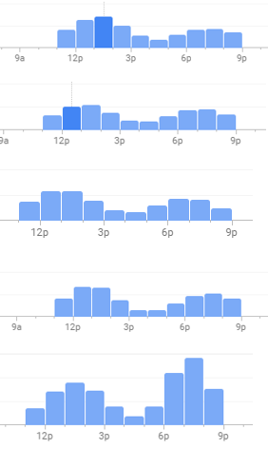

**ACTIONS:**

Based upon the Strategic SWOT Analysis, we devised three categories of actions for Boca 31 to follow:

Specials and Promotions  *Fortified Defense, Diversified Growth*

1. *Happy Hour*
   1. Boca 31 serves high quality food, made by world-class chef. However, the data collected from both Google and Yelp shows that customers stay at the restaurant for an average of 30 minutes (See Insights Section). Based upon our insights, besides the **quick service** we attribute this significantly to the noises from the nearby train. In order to combat this frequent overturn of customers, we proposes the development of happy hour drink specials. A 2013 report from the University of Pittsburgh, suggests that happy hours increase frequency of smiling as well as enhance positive emotions. The first step would be the implementation of a half-price sangria every time that a train horn went off. This would make customers overlook the noise from the train, because it is attached to a benefit for them. Further, the drink offered would be the in-house made sangria because of its cost effective nature. Additionally we noticed that the slowest hours during the week are between the hours of 3-6PM. Thus, we proposed that Boca 31 introduce a happy hour during this time on the weekdays in order to increase customers during this time frame creating **strong brand loyalty**. Due to the nature of the promotion, we hope to attract a younger crowd of people to Boca 31. That being said, we propose the implementation date of February 2018. That way the universities in Denton are in session and there is a large population of prospective clients.
2. *Buy-one Get-one Half-Off Sandwiches* 
   1. The sandwiches at Boca 31 are the most expensive items on the menu, and among the most infrequently purchased. In order to increase the number of sandwich sales, we propose a buy-one get-one half-off special on certain days of the week. This would be a more **affordable** option for people to get their **Latin street food** fix. This special would encourage customers to bring friends or family and would stimulate the sales of the sandwich. This will also not harm Boca 31’s overall profits because the sandwich is their most profitable product. We hope to start implementing this special in February 2018. Much like the happy hour special, the sandwich deal will be implemented in a time when school is in session, in order to capitalize on the frequent customers at Boca 31.

Improve physical presence  *Fortified Defense, Diversified Growth, Un-Differentiation*

Branding Boca 31 must be done physically to reinforce the brand positioning. Within the action to improve physical presence there are several sub-actions that we propose be implemented:

1. *Customer Art Wall*
   1. Seeing as Denton is an artsy town, we propose the creation of a customer interactive, art wall. To do this, Boca 31 would print out a design filled coloring sheets featuring the restaurant's logo. Coloring materials such as markers and crayons will be placed by the water stations throughout the restaurant, to promote easy accessibility. After guests finish their art piece, it will be hung on a designated wall in the restaurant. Much like how drawings are hung on refrigerators at home. This would reinforce our salience of the **home away from home experience**, knowing one has a **sincere** environment to express themselves in. This activity will warrant participation from all age groups, and will promote the length of time that customers stay at the restaurant. Thus, allowing **a place for everyone**. Given the simple nature of this added feature, we propose an early implementation date of April 2018. The cost to produce this wall is minimal and would solely require the printing of coloring sheets, as well as a box or two of crayons to be distributed. To get an assortment of crayons in bulk it would be about $30 and a 1500 pack of paper would cost about $15. Below is a potential coloring sheet Boca 31 could have:

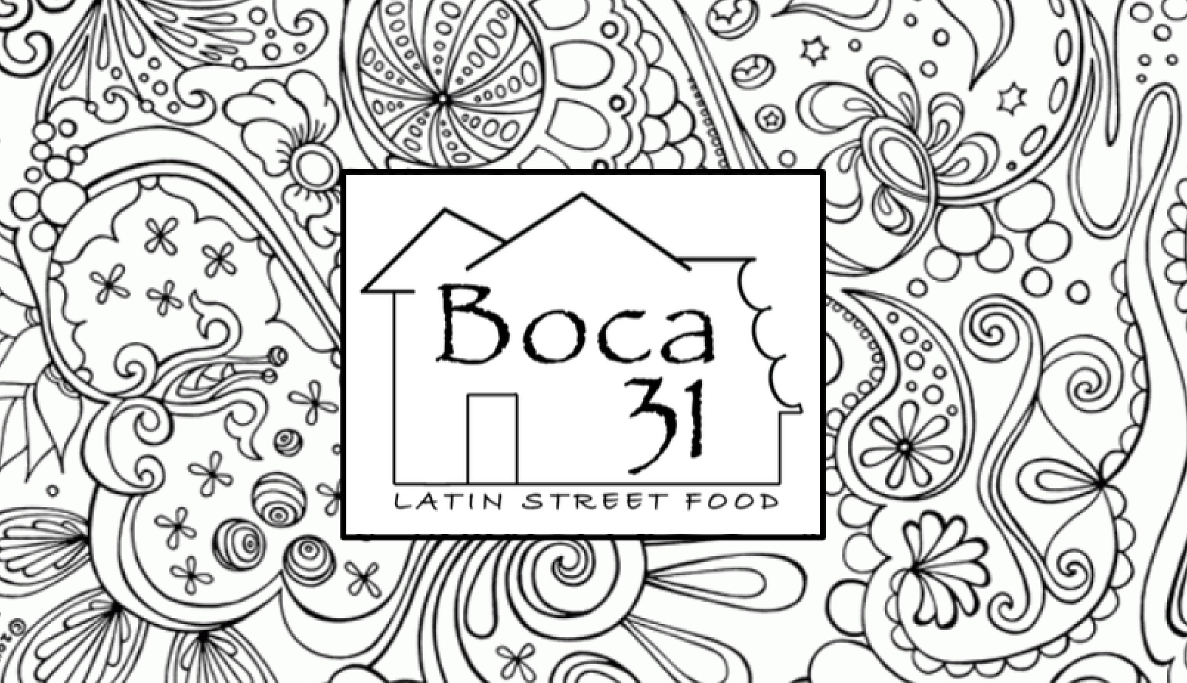

1. *Social Media Chalkboards*
   1. Keeping with the chalkboard menu theme, strategically placed chalkboards will display the social icons and corresponding handles to encourage follows and shares. This is an easy way to increase **awareness** of Boca 31’s online presence. This simple and cost effective addition will be implemented in April 2018. The cost for a 12’ x 18’ inch chalkboard averages at around $20. The number of chalkboards used will be to Boca 31’s discretion. However, we suggest a minimum of two indoors and two outdoors. With 4 total, at $20 a piece, this would be $80.
2. *Clear Cups for Specialty Drinks*
   1. Incorporating clear cups that are used for BOCA 31’s specialty drinks will showcase the colorful drinks, and make them more enticing for the consumer as well as others in the restaurant. We believe that this simple change will increase sales because other customers because the natural color of the beverages will be showcased and peak the interest of others in the restaurant. The cost to purchase the clear cups is 195.00 for a case of 1000. We propose the use of these cups in April 2018. Our reasoning for April is as the weather starts to warm up more specialty drinks will be ordered.
3. *Place Logo on to-go items*
   1. One of the simplest, yet most effective actions we are proposing is the added logo identification on current to-go items. For the time being, this can be done by creating stickers with the logo, that will be placed on existing cups, to-go containers, and bags. Eventually, we propose that it will be most cost effective for Boca 31 to have custom to-go containers created. This is a cost effective way to provide advertising for Boca 31 increasing **brand awareness**. The timing for the introduction of labeled containers will began in March 2018. The cost of this endeavor is $165 per thousand stickers.
4. *Improve Sign Presence* 
   1. Boca 31 is in a prime location with its proximity to not only the square, but two large universities. That being said it can be difficult for those looking for the restaurant to find the location because of the lack of roadside signage. Additionally, an increase in signage would increase the traffic of potential customers who are just driving by. Based upon the cost for Boca 31’s previous sign, we estimate that the cost will be a one time charge of $550. This will need to be created at the same time that the logo is introduced. Thus, we are proposing the production of a new sign in January 2018.
5. *Improve Restaurant Layout* 
   1. The customer and employee flow at the kitchen/register area causes a lot of congestion and a bit of an uneasy feeling as the customer is trying to order. Relocating the kitchen access point on the counter on the opposite side of the opening would give much needed space to customers queuing up at the register and free the walking space from the kitchen to the door, since the majority of seating is outside. This would also allow the menu to be viewed easier, as customers will not be standing immediately next to it. Also, to provide a more friendly, personal experience, moving the register where it is not an obstruction between the employee and the customer would give a more welcoming feeling to the customers as they choose their meals**.** This would cost little if any to implement and could be easily reverted if flow change result are undesired. We hope to implement this improvement in June 2018.

Improve digital presence *Fortified Defense, Integration Growth*

1. *Reimagine the logo*
   1. In order to further establish a strong brand image, it is important for Boca 31 develop a new logo that better encompasses the **home away from home experience**. This new logo will be featured at the physical restaurant as well across various websites, and social media platforms. Being that Facebook is currently Boca 31’s largest form of communication to patrons, an official logo needs to be used with top priority placement. The implementation of the logo is proposed to be unveiled during January 2018. This change will emphasize the positive growth opportunities to come from Boca 31. The estimated cost of the proposed logo from Hernando Rozo is about $600. Though expensive, this logo will support the brand for years to come and will be a staple in the necessary increase in **brand awareness**. Below is what Hernando came up with for a logo after we proposed our ideas. We felt incorporating the Boca 31 house was extremely important as it goes well with our reference market in conveying the **home away from home experience**. There is a bite in the right side of the house to show that not only does Boca 31 provide a homey feeling, but it also has **high quality** food. We chose homey, vibrant colors, that not only represent the psychical structure of the building, but also represent the **warm** feeling that customers have while eating at Boca 31.

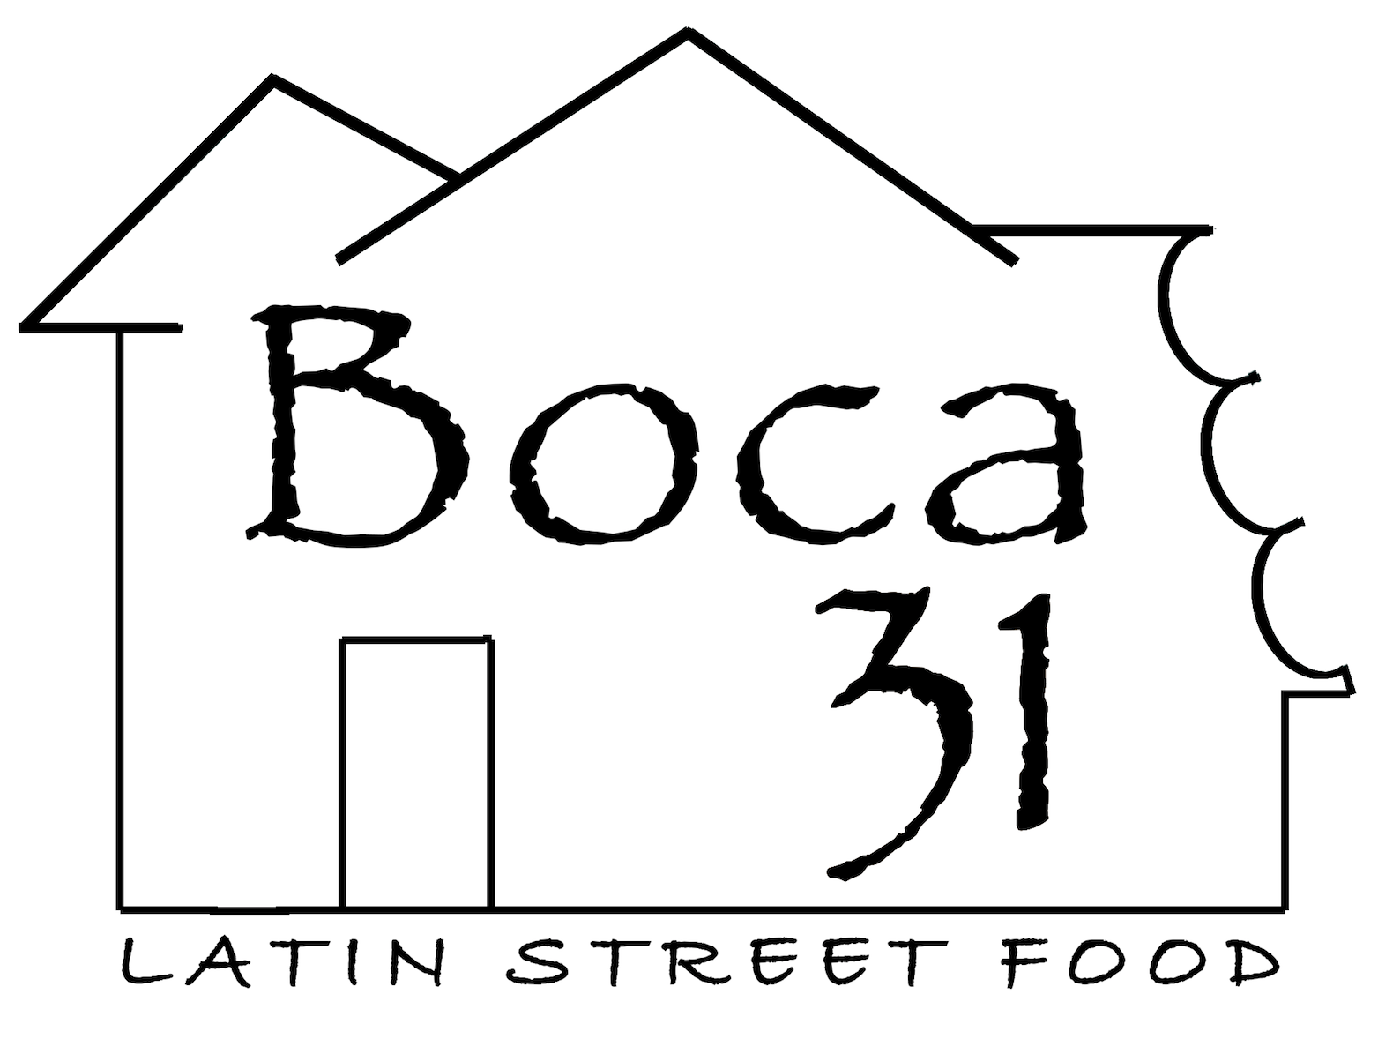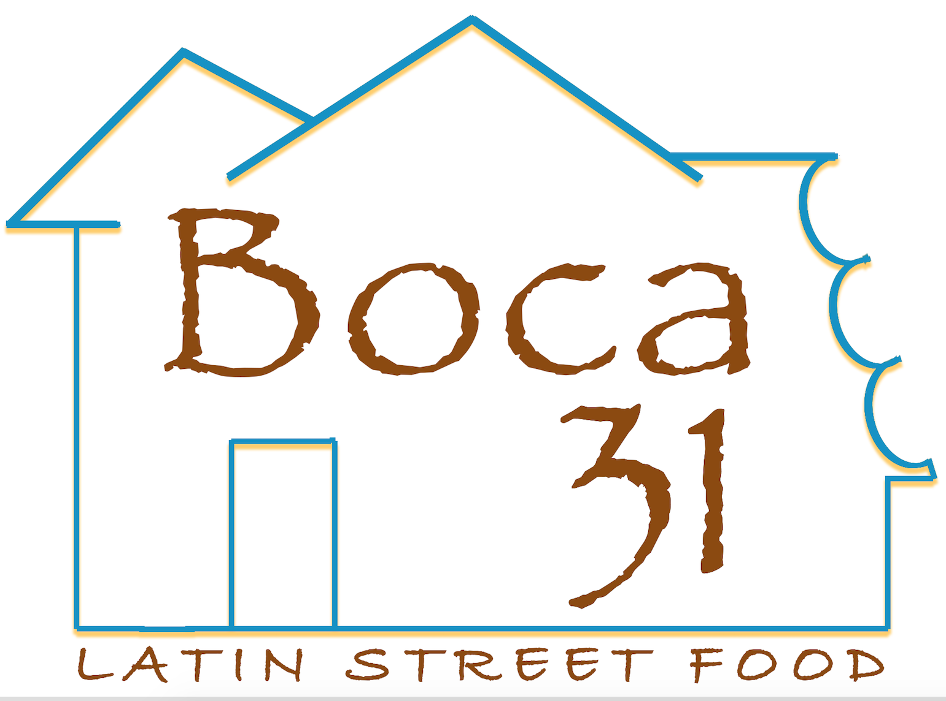

1. *Create a Website*
   1. We believe that it would greatly benefit Boca 31 to establish even the most basic website. A 2015 survey conducted by the score indicated that 91% of consumers who have a positive web visit will also visit the physical location of the business. A website would allow Boca 31 to have its own outlet to keep people aware of what they are doing. A website could also highlight photos of the food giving people a glimpse of the **strong Latin heritage** it possesses. Also, it would be a connection point for all the social media that Boca 31 uses. Potential features of the website could include, contact /information, a map with directions, restaurant history, and a menu.. We propose the construction of a simple yet functional website in January 2018. However, given the creation process, the website will take a few months to complete. Based upon this timeline, we hope to implement the operational website in March 2018. The cost of this website will be $2,750 from designer Hernando Rozo. However, the benefits of the website are invaluable for Boca 31.
2. *Utilize Single Platform to streamline menu online*
   1. The website “SinglePlatform” is an online tool utilized by small businesses in order to streamline their menu online. Meaning, that Boca 31 can upload and make changes to their menu on a single platform, and the changes will be seen across the internet. The service partners with large companies such as Google, Yelp, Zagat, and TripAdvisor to ensure maximum visibility for the restaurant. For people unsure of the kinds of food and beverages that Boca 31 serves, the tool “SinglePlatform” would allow the restaurant to easily streamline a menu that displays on many platforms across the internet. Having the Boca 31’s menu in many places across the internet, including their Facebook page, would be very beneficial for the restaurant and any potential customers. This is due to the increased visibility of the **affordable** menu, ease of access for customers and low maintenance for the restaurant. The single platform is a proposed idea that we would look to implement in March 2018 along with our website. . We would like to wait a year before creating an account on single platform. To allow our website be established before launching single platform. The cost for the basic version of the service is $99 a month.

**Implementation Timeline:**

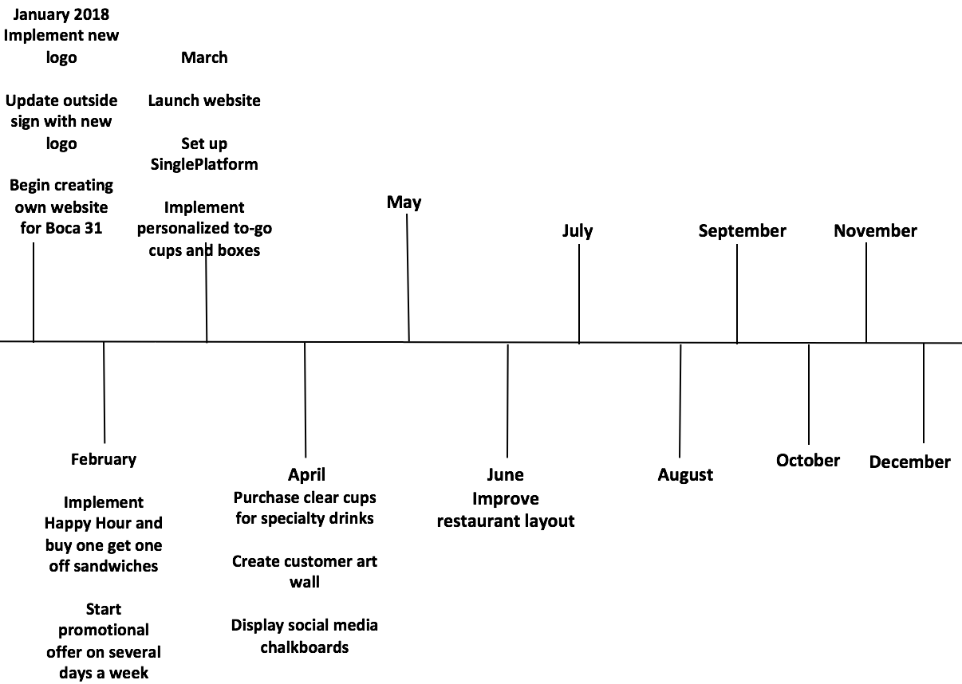

**2018 Budget**

**One-Time Purchases**

* Logo: $600
* Website: $2,750
* New Building Sign: $550
* Chalkboards: $80 for four
* Art Wall Supplies: $45

*Total: $4,025*

**Monthly Purchases**

* 1000 Custom Plastic Cups: $195
* 1000 Logo Stickers for To-Go: $165
* SinglePlatform: $99

*Total: $459 Per Month Starting in March ($4,590)*

**Total Yearly Cost: $8,615**

* **CBBE Model:**

The CBBE model defines a brand with the use of 6 brand building blocks. The brand building blocks help the brand answer four questions that consumers directly or indirectly ask themselves about the brand. Together all these elements create a strong brand equity.

The first level, from the bottom up, consumers ask the question: *“who are you?”* Salience answers this question. Boca 31’s salience is: **Latin street food**, **moderate brand awareness**, along with the **home away from home experience**.

The next level answers the question: “*What are you?*”. The two brand building blocks used to answer this question are Performance and Imagery.

Performance is the influence of what consumers experience, what they hear about, and what it tells consumers about the brand. Boca 31 is **affordable**; their prices are in sync with other competitors. It’s a **reliable choice** meaning their customers can count on Boca 31 to always provide hot, good tasting, Latin food. Lastly, it provides **quick service**, by always getting the food out fast. The abstract side of the need, is the more psychological side of the needs.

These are defined by Imagery. Boca 31 is a **place for everyone**, that provides **a strong Latin heritage**, in a casual **environment** with a **sincere** staff.

The third layer of the pyramid is regards to the question “*what about you*?”.  After a brand is able to create brand identity and a brand meaning, the next level is brand response. The brand response is derived from consumers’ opinions and feelings towards the brand. It consists of Judgements and Feelings.

Within the Judgement category, Boca 31 provides food that are **high quality**, and they show **superiority** by being unique as opposed to some of their competitors.

Within the Feelings category, the emotional feeling customers get while being there are: **warmth, fun, and security.** Boca 31 wants all their customers to feel as if they are in his home. Finally, the top level answers the question: “*what about you and me*?” Resonance focuses on the brand relationship. Boca 31 creates a **strong brand loyalty**, as 75% of their customers are repeat customers and a **strong attitudinal attachment**.

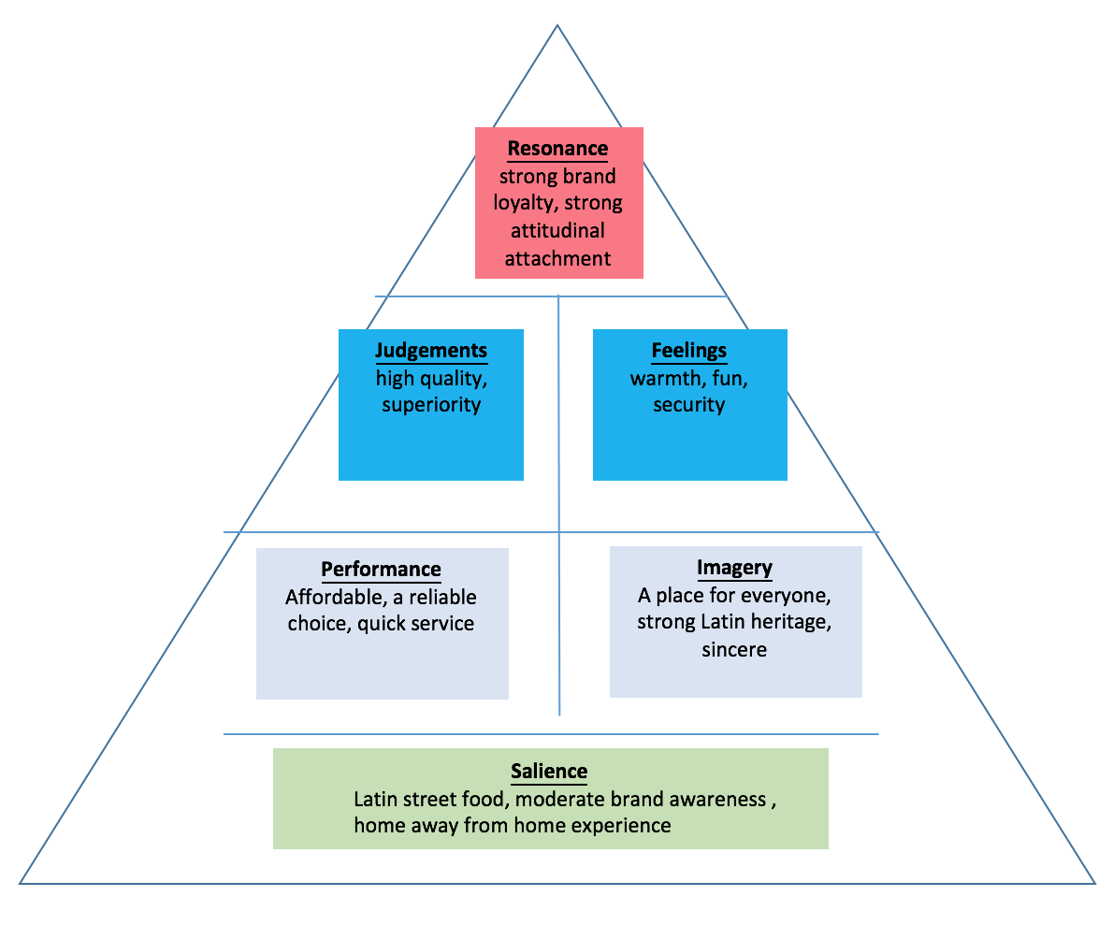

**Conclusion:**

While highly acclaimed chef Andres Meraz welcomes patrons through his restaurant, he wants to make them feel a part of the family in a home away from home experience that treats them to the delicious menu Boca 31 offers. Since its opening, the restaurant has been featured in numerous articles and has almost perfect ratings on Google reviews and Yelp. However, reaching new customers can be an issue. The lack of a website, daily specials and street sign can make it difficult for people to find out about the restaurant. These few problems are fixable however and will make it much easier to bring patrons into Andre's home.

**References:**

About. (n.d.). Retrieved October 18, 2017, from http://kdb.org/about/  
  
SHOP Denton. (n.d.). Retrieved October 18, 2017, from https://www.cityofdenton.com/business/get-involved/shop-denton   
  
Mi Casita | Denton, TX. (n.d.). Retrieved October 18, 2017, from http://micasitafood.com/  
  
Award Winner. (n.d.). Retrieved October 18, 2017, from https://awards.citybeatnews.com/MI-CASITA-DENTON-TX  
  
Mr. Chopsticks. (n.d.). Retrieved October 18, 2017, from http://www.mrchopsticks.com/index.html  
  
Mr. Chopsticks. (n.d.). Retrieved October 18, 2017, from http://www.americanregistry.com/business/mr-chopsticks/5101272   
  
About Cracker Barrel®. (n.d.). Retrieved October 18, 2017, from https://www.crackerbarrel.com/about   
  
Welcome. (n.d.). Retrieved October 18, 2017, from https://www.backyardonbell.com/#modern-organic-thai   
  
Austin St. Truck Stop. (n.d.). Retrieved October 18, 2017, from http://www.austinsttruckstop.com/

Consumers will travel 17 mins to reach a local business. (2017, April 11). Retrieved October 18, 2017, from https://www.brightlocal.com/2014/05/01/local-business-travel-times/

Gallup, I. (2017, January 11). Americans' Dining-Out Frequency Little Changed From 2008. Retrieved October 18, 2017, from http://news.gallup.com/poll/201710/americans-dining-frequency-little-changed-2008.aspx

Goldin, B., & Caskey, B. (2017, March 28). Fast Casual and Supermarket Prepared Foods: Are they losing steam [PDF]. Chicago, IL: Pentallect Inc

Lack of websites common pitfall for small businesses. (n.d.). Retrieved October 18, 2017, from http://www.post-gazette.com/business/pittsburgh-company-news/2015/01/06/Lack-of-websites-common-pitfall-for-small-businesses/stories/201501060018

Lisa Jennings | May 19, 2017. (2017, May 19). Report: Consumers prefer independent restaurants over chains. Retrieved October 18, 2017, from http://www.nrn.com/consumer-trends/report-consumers-prefer-independent-restaurants-over-chains

Food Trucks: Market Research Report. (n.d.). Retrieved October 18, 2017, from <https://www.ibisworld.com/industry-trends/specialized-market-research-reports/consumer-goods-services/food-service-drinking-places/food-trucks.html>

Dooley, R. (2013, January 15). Happy Hours Promote Social Bonding - Proof at Last! Retrieved November 27, 2017, from <https://www.forbes.com/sites/rogerdooley/2013/01/15/happy-hours/>